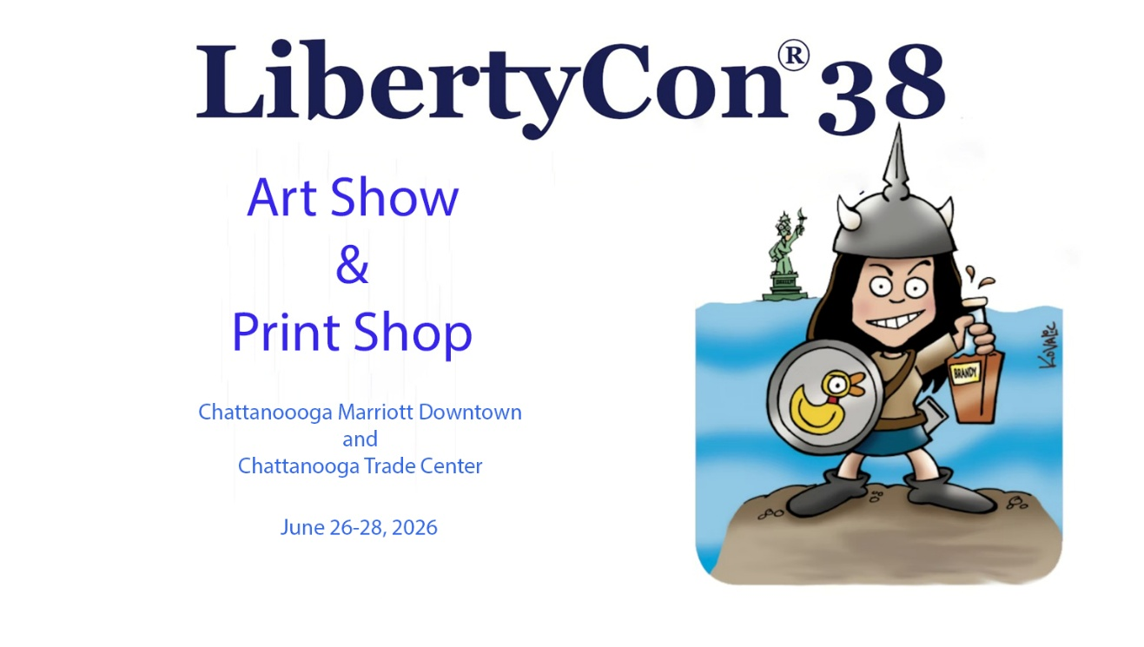

LIBERTYCON®38 ART SHOW and PRINT SHOP RULES

- LibertyCon®38 will be held June 26 – 28, 2026 at the Chattanooga Marriott Downtown and the Chattanooga Convention Center. The Art Show will be in the Chattanooga Convention Center. The Art Show director is Ann Robards. LibertyCon® is pleased to feature John Kovalik as our Artist Guest of Honor.
- Works that are judged to be AI generated will not be permitted in the Art Show.
- Artist check-in: Friday from 1:00 pm -4:00 pm & check-out Sunday from 1:00 pm.-3:00 pm. Please check out by 3:00 pm.
- Art Show Hours: Friday: 4:00 pm – 10:00 pm, Saturday: 10:00 am - 4:00 pm, and Sunday: 9 am – 12:00 noon on Sunday. The Art Auction starts at 7:00 pm on Saturday. Art not picked up by 12:00 noon on Sunday will be returned to the artist as unsold.
- Art Show Space: Due to space considerations artists are limited to 4 4x4 panels, 1 full table (6’x30”). Please note any table space in the Art Show is for 3D art.
- The Print Shop: LibertyCon® will host a Print Shop. Due to space limitations, your Print Shop table will be located with your panels. The Print Shop tables will be 6’x15” (classroom tables).
- FEES MUST be paid in advance of the show and be accompanied by a signed copy of the rules. If any space is left, walk-ins will be accepted on a first-come, first-served basis.
- Fees for Art Show display space are: $16.00 per 4' x 4' panel, $8.00 per 1/2 table (3’ x 30”), $16.00 per full table (6’x30”). The Print Shop fee is a flat fee of $15.00. LibertyCon® does not charge a commission on sales.
- Mail-in Art: LibertyCon accepts mail-in art, but we require a handling fee of $10.00 per artist for mail-in art in addition to return postage. Mail in art must be received by the Director on or before Friday, June 19, 2026, to be displayed in the Art Show. All mail-in art must be accompanied by a check for return postage. Unsold art will be returned within one week of the close of the convention. Every attempt will be made to return art in the manner desired by the artist. Please make sure your paperwork is adequately noted and include a return address label. Mail art to Libertycon Art Show, c/o Ann Robards, 3546 Cottonwood Lane, Chattanooga, TN 37406. Please contact the Director for any questions and/or clarifications.
- Original artwork and limited edition prints, at the discretion of the artist, will be displayed in LibertyCon’s Art Show. There will be a Print Shop for other prints.
- All artwork entered in the show shall contain the following information: Artist, Title, Medium, Original or Print, Minimum Bid (or NFS), Direct Sale (if any), After Auction (if any), Category (SF, Fantasy, etc.), Artist Classification (Amateur or Professional), Number of Prints for this series\title to be entered (Print Shop).
- CONTROL AND BID SHEETS are computer generated. Participating artists will be emailed the necessary form. To facilitate check- in, this form must be returned by June 19, 2026. Realizing that things happen and change may be necessary, it will be possible to edit your entries, one time, after submission.
- NO PUBLICATION RIGHTS WILL BE SOLD BY LIBERTYCON®. Anyone wishing to purchase publication rights must negotiate with the artist.

- Art with 3 bids or more will go to the Voice Auction on Saturday evening. When the Art Show closes at 4:00 pm Saturday any pieces with 3 or more bids will be taken to the live Voice Auction. At this time, any pieces with 1 or 2 bids will be awarded to the highest bidder on the bid sheet.
- LibertyCon® reserves the right to add art with no bids to the Voice Auction and, unless otherwise instructed, will request a first bid equal to the minimum bid on the bid sheet.
- Photography will not be allowed except with the consent of the artist. The artist must inform art show personnel that photography will be permitted.
- Artists will be paid at the convention. For mail-in artists, checks and artwork will be sent separately. All artists will receive a copy of the completed control sheet. Please check it carefully. Should you find an error on your control sheet, please let us know so that it may be corrected.
- CREDIT CARDS: LibertyCon® will accept credit card payments for Art Show sales from attendees, as well as from artists for Art Show fees. We also accept cash and checks. Please make checks payable to Libertycon.
- We are not responsible for theft or damage to pieces displayed. We do not provide insurance coverage for art entered in the show. While we make a reasonable attempt to protect your art, we recommend you verify that your insurance coverage extends to display in the show.
- For all correspondence & artwork mailing: Ann Robards, 3546 Cottonwood Lane, Chattanooga, TN 37406. Email: artshow@libertycon.org. Email is preferred for correspondence.
- ART SHOW AWARDS will be limited only to ORIGINAL WORKS OF ART. Unique digital artwork is original for the purpose of these awards.
- FEEDBACK – Please feel free to share any constructive criticism, suggestions or ideas on how to make our Art Show better for the artists and the attendees.
- SALES TAX at the rate of 9.25% will be collected for all artwork sold and remitted to the state of Tennessee on behalf of the artist.

